 |  | HOD Governor
 |  | March 2023
Hebrew Order of David  Governing Lodge  info@hodnorthamerica.org |  | 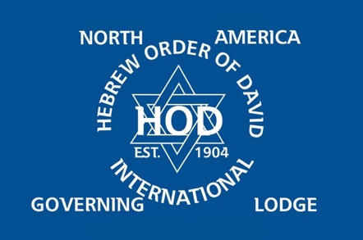
HOD North America  Governing Lodge  Executive  President: WB Lawrence Barris  Deputy: WB Leonard Laser  IPP: WB Alan Smirin  Past: WB Les Kraitzick  Past: WB David Joss  Past: WB Mario Oves  Secretary: WB Cyril Braude  Treasurer: WB Joe Blog  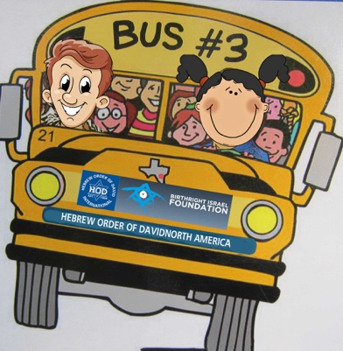  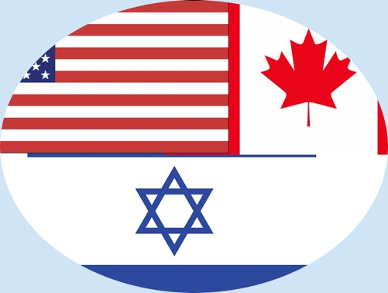  Scribe: WB Paul Wainstein |  | 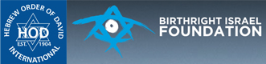  Exciting News!  In 2022 HOD began thinking about a possible major fundraising project when a good friend of Worthy Brother Jeff Kalwerisky and Worthy Brother David Joss was invited to make a presentation to Lodge Carmel in Atlanta. That good friend was Doug Ross, who serves as Vice Chair of Birthright Israel Foundation. Doug's presentation made HOD aware of the urgent need for funding for the program which has provided this life-changing experience to 800,000+ young Jewish adults from 68 countries over the past 23 years.  HOD has agreed to undertake a special project which will help raise funds so that Birthright Israel Foundation can continue its vital work on behalf of the Jewish people. The cost to send one participant on a Birthright Israel trip is $4,500, with an entire bus of 40 participants costing $180,000.  Our goal is to fund a bus of young people, and perhaps even more. This campaign was enthusiastically received on a recent Zoom call with all the North American Lodge Presidents and Vice Presidents! An email updating this unique and exciting project will be sent to all the Lodge Brethren around mid-April, with the campaign staying open and active for at least two weeks.  Stay tuned.... we will be sharing further good news in the coming weeks!
Thought of the Month  A positive attitude may not solve all your problems, but it will annoy enough people to make it worth the effort. |  | HOD Biennial Conference 2023  The Hebrew Order of David International will hold its Biennial Conference in London, UK from Thursday May 11 until Sunday May 14, 2023.  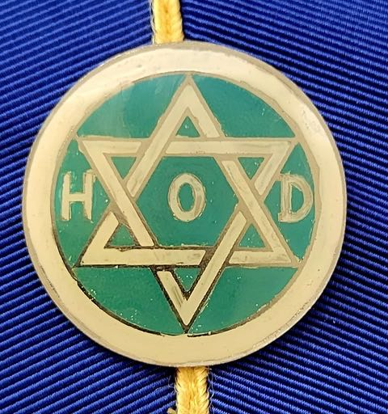  At this time, HOD North America (HOD NAGL) expects to have seventeen brethren at the conference. The conference will also be attended by brethren from Israel, South Africa, and the UK.  The conference will include a welcome social dinner on Thursday evening, a breakfast workshop with a Shabbat service and formal dinner on the Friday and a shul service and kiddush on Saturday. On the Sunday, a social brunch is planned at the home of current HOD Grand Lodge Deputy President Anton Teper, followed by a Third-Degree Ceremony, the installation of HOD Governing Lodge and a Conference session. The conference will hold a formal dinner after the Sunday afternoon events.
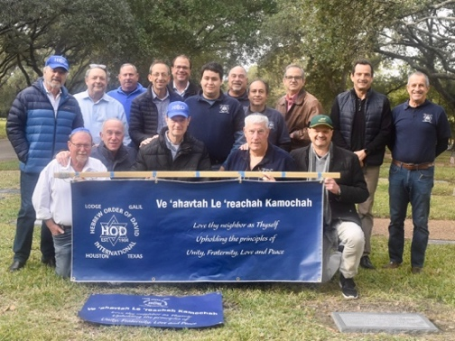 |  | 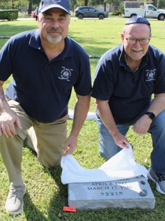  Gravestone Project  The Hebrew Order of David Gravestone Project has proved to be successful in terms of achieving its goal of meeting the highest form of charity; doing mitzvahs for people who can never thank you, and for spreading the good word about HOD. In Houston, where the project was initiated, already over 140 gravestones have been unveiled.  The project has been picked up by the HOD Lodges in Atlanta, while lodges in Dallas and the UK are working on getting it started.  Kol Hakavod for all those working on this wonderful HOD initiative!
HOD International Websites
HOD International: https://www.hodavid.org/
HOD North America: https://hodnorthamerica.org/
HOD UK: https://hebreworderofdavid.co.uk/

l
Hebrew Order of David North America  Lodges  Atlanta:  Bezalel  Carmel  Magen David  Shimshon  Boca Raton:  Tamir  Dallas:  Shimon Peres  Houston:  Galil  Tikvah  San Diego:  Edmond J Safra  Toronto:  Ilan Ramon |  | 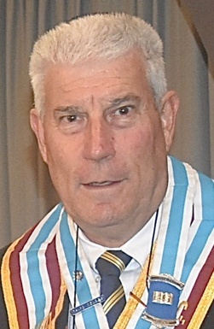  Brotherly profile  President Worthy Brother Lawrence Barris  HOD North American Governing Lodge President, Worthy Brother Lawrence Barris believes that he is living a wonderful life. Growing up in South Africa, Lawrence would occasionally help his entrepreneur dad in the family's business. Lawrence attended Theodor Herzl Jewish Day School in Port Elizabeth where he excelled in athletics, including tennis, cricket, squash, table tennis, soccer, hockey, and rugby. In his "spare" time, he loved to surf. He chuckled "I excelled in everything but my education!"  After high school, Lawrence entered the South African Police Force which was part of the military training required of all young South African men at that time. Three months after his stint in the South African Police Force, Lawrence met the love of his life, Sharlene, through a mutual friend, Bro. David Kolnick and wife Phyllis, also now resident in Houston! It was love at first sight!  They dated for the next five years before marrying in a civil ceremony because Lawrence had applied for his Green Card. This ceremony took place using a wedding band owned and used by Sharon Scheckter, wife of Bro. Martin, also now resident in Houston! Later that year, 1984, they had a Traditional ceremony and were married in Shul in Port Elizabeth. They obtained their Green Cards and moved to Houston. They are proud parents of two married children and are blessed with two wonderful grandchildren. Since arriving in Houston, Lawrence started a number of businesses which have included a high-end chocolate and coffee company an A/C and plumbing business, and a janitorial chemical blending business. After those ventures, Lawrence worked for 12 years with HOD Brethren John and Clive Hess in their computer and metal recycling business. Lawrence now owns and operates commercial/industrial business parks.  Lawrence attributes much of his success as a businessman and as a father to lessons learned from his parents. They taught him the values of discipline, punctuality, respect, fair mindedness, balance, and honesty. He developed his passion for serving others through his father’s and grandfather's involvement in the Hebrew Order of David in South Africa. Lawrence became one of the youngest members inducted into the Hebrew Order of David Lodge Hillel at the age of 21.  When Lawrence and Sharlene emigrated to the U.S., Lawrence was disappointed to learn that Houston did not have a lodge. In 2015, while visiting in Dallas, Lawrence was introduced to several ranking HOD Lodge Brethren from Atlanta who were consecrating the Shimon Peres Lodge. They told him that they were happy to help him start a lodge in Houston. With their help, the Houston Galil Lodge was consecrated in 2015 with about 30 founding Brethren. This was accomplished by an incredible team of founding members that have contributed greatly the Lodge Galil’s success.  Worthy Brother Lawrence was raised to the third degree in March 2018. He was appointed to North American Governing Lodge in 2020, becoming Governing Lodge President in 2021.

